

**MEMORANDUM**

**DATE: October 10, 2009**

**TO: Laboratory Group E**

**Steven Grant, Kristyl Bently, Michael Burton**

**FROM: Tony Butterfield**

**Engineering Training Supervisor**

**SUBJECT: Clear Heated Stage**

Our lab is studying perfluoropentane microdroplets. These particles are to undergo a phase change from liquid to vapor in the body upon heating with focused ultrasound or radio waves, to therapeutic ends. We want to visualize these droplets and their transition to bubbles with light microscopy. However, the only heated stage we have is opaque.

During the last project period, Group D characterized the first iteration of a clear stage design. You may want to talk with them about their experience and findings, but your project will be significantly different. Firstly, the original design is slightly too tall, and only works with certain microscope objectives. The stage you will be working with has been shortened. Secondly and most importantly, you are to incorporate feedback control of the stage temperature into the system.

I propose a fairly simple design, as shown the following figure.

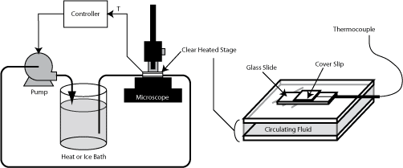

In this design, a fluid from a heat or ice bath is pumped between two clear plates, which make up the stage. On top of the stage will be the glass slide and the sample of interest. The controller will adjust the pump speed in order to compensate for the heat loss (or gain) that will occur in the stage (and tubing) exposed to room temperature. The temperature to be controlled is temperature of the sample. You may alter this design if you feel some other may better suit our needs; however, discuss alterations with me before you commit to them to assure you do not violate some of the design objectives.

Your first task will be to assemble the system: the stage, pump, temperature bath, tubing, controller and thermocouples (you will likely want to measure more than one temperature). I will provide you with the needed materials and equipment. Next you should conduct some appropriate tests to approximate the transfer function of the system. In your report, please indicate the degree to which the transfer function you find agrees with theory, assuming the stage is perfectly insulated on the acrylic surfaces.

Choose a control scheme (P, PI or PID) that will best give the ability to quickly and accurately reach a new temperature set point. Find the Ziegler-Nichols control settings and run the system at those settings, as a starting point for controller tuning. While we want as quick of a response as possible, our microdroplet emulsion is irreversibly temperature sensitive, and therefore it is important to avoid overshoot. Adjust the tuning parameters accordingly and report your recommendations.

It is very important that the temperature we control be as close to the temperature experienced by the microdroplet samples as possible. It is not possible, however, to insert a thermocouple into each sample. We have three main methods of preparing our samples: 1. The sample is injected into a microfluidic channel in a cyclo-olefin copolymer slide; 2. The sample is sandwiched between a glass slide and a glass cover slip; 3. The sample is between a glass slide and glass cover slip, but the cover slip is raised to the height of a glass slide to allow for diffusion of droplets. I will show you these different methods.

As a side aspect to this project, please assemble a test slide that will give us the most accurate temperature measurements for at least sample preparation method 1 or 3. You do not need to repeat the control experiments for each test slide—only develop your control scheme with either the 1st or 3rd method—but comment on any possible difference introduced by use of the different methods.

Please contact me with any questions you may have, and I look forward to meeting with you regarding this project on or before Monday, October 19, 2009.